Solution to every third end-of-chapter problem
Basics of Engineering Economy, 2nd edition
Leland Blank and Anthony Tarquin

Chapter 8
Breakeven, Sensitivity, and Payback Analysis

8.1 (a) Q_{BE} = 1,000,000/(9.90 – 4.50)
= 185,185 units

(b) Profit = R – TC
= 9.90(150,000) – 1,000,000 – 4.50(150,000)
= $-190,000 (loss)

(c) Profit = R – TC
= 9.90(480,000) – 1,000,000 – 4.50(480,000)
= $1,592,000

8.4 Let x = hours per month billed to realize a profit of $15,000

15,000 = -900,000(A/P,1%,120) – 1,100,000 + 1,500,000(A/F,1%,120) + 10(90)x
15,000 = -900,000(0.01435) – 1,100,000 + 1,500,000(0.00435) + 10(90)x
900x = 1,121,390
x = 1246 hours/month

8.7 (a) Plot shows maximum quantity at about 1350 units. Profit is about $20,000.

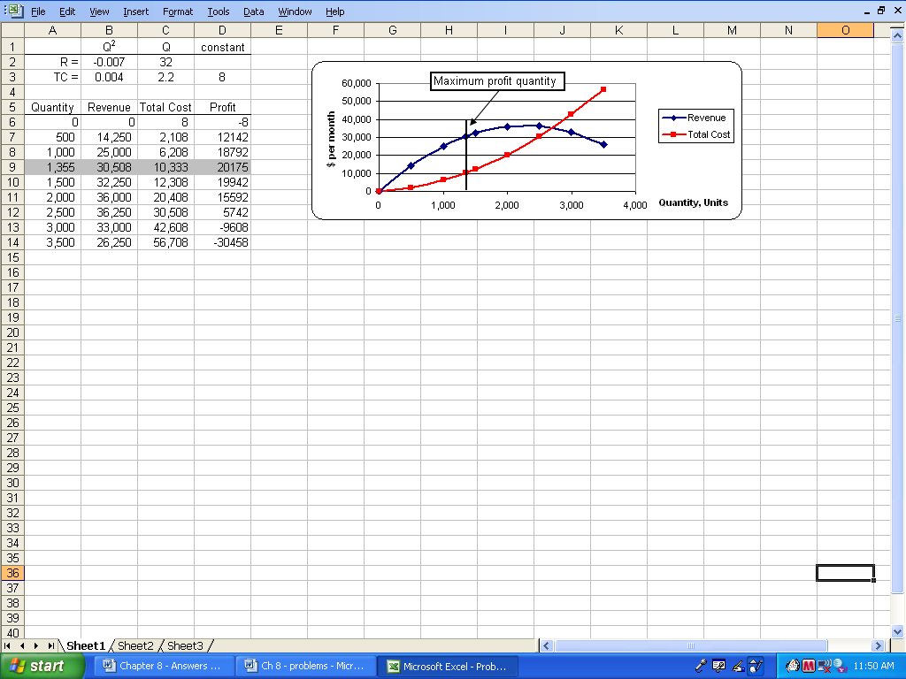

(b) Profit = R – TC = (-0.007 - 0.004) Q² + (32-2.2)Q - 8
= -0.011Q² + 29.8Q - 8

Q_{p} = -b/2a = -29.8/2(-0.011)
= 1355 units

Max profit = -b²/4a + c = -29.8² / 4(-.011) - 8
= $20,175 per month

8.10 (a) Using the relation PW = 0, select different i values and solve for n. Details for
i = 8% and 15% are shown.

0 = -3,150,000 + 500,000(P/A,i%,n) + 400,000(P/F,i%,n)

i = 8%, n = 8: PW = -3,150,000 + 500,000(5.7466) + 400,000(0.5403)
= $-60,580
i = 8%, n = 9: PW = -3,150,000 + 500,000(6.2469) + 400,000(0.5002)
= $173,530
n = 8.2 (interpolation)

i = 15%, n = 19: PW = -3,150,000 + 500,000(6.1982) + 400,000(0.0703)
= $-22,780
i = 15%, n = 20: PW = -3,150,000 + 500,000(6.2593) + 400,000(0.0611)
= $4090
n = 19.8 years (interpolation)

(b) Retention ranges from 8 to 20 years for varying i values. This is a perfect
example where the spreadsheet is easier. Use the NPER function.
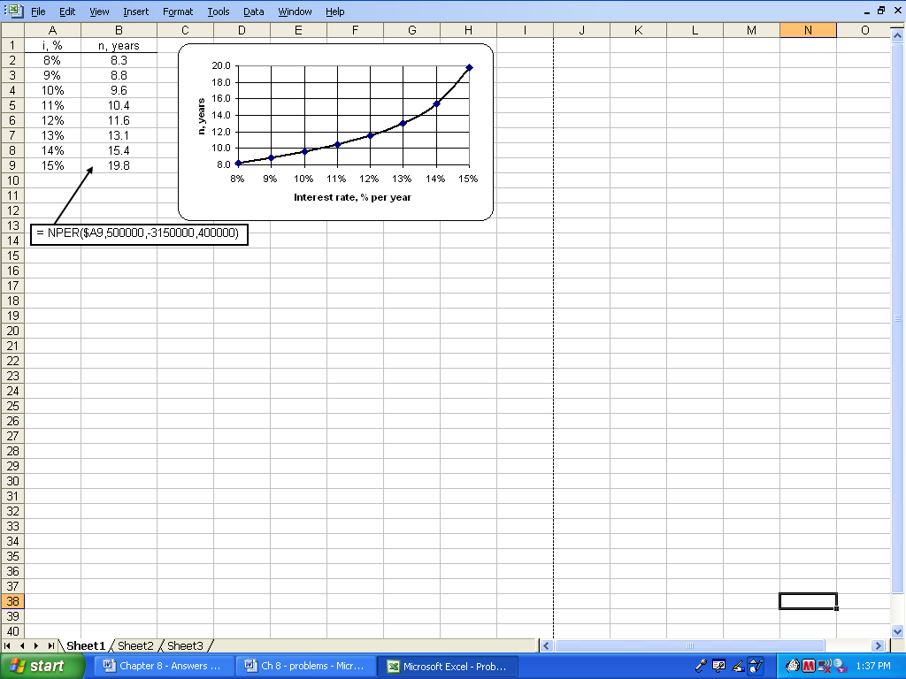

8.13 Let P_{asp} = maximum $/mile for asphalt

-2,300,000(A/P,8%,20) - 483 = -P_{asp}(A/P,8%,10) – 774
-2,300,000(0.10185) - 483 = -P_{asp}(0.14903) – 774
P_{asp} = $1,569,912

8.16 Let x = square yards per year to break even

-109,000 – 2.75x = -225,000(A/P,8%,15) – 13x
-109,000 – 2.75x = -225,000(0.11683) – 13x
10.25x = 82,713
x = 8070 square yards/year

8.19 Let x = ads per year

-21 x = -12,000(A/P,10%,3) -55,000 + 2000(A/F,10%,3) – 5x
-21x = -12,000(0.40211) -55,000 + 2000(0.30211) – 5x
16x = 59,221
x = 3701 ads

8.22 Let x = production in year 3

-40,000 – 50x = -70,000 – 12x
38x = 30,000
x = 789.5 or 790 units

8.25 (a) Let T = number of tons. Solve relation AW₁ = AW₂ for T.

Variable costs (VC) for each machine
VC₁: 24T/10 = 2.4T VC₂: 2(24)T/6 = 8T

-123,000(A/P,7%,10) – 5000 -2.4T = -70,000(A/P,7%.6) – 2500 – 8T
(8-2.4)T = -70,000(0.20980) – 2500 + 123,000(0.14238) + 5000
5.6T = 5327
T = 951.2 tons

If tonnage is less than breakeven, select machine 2 since the slope is steeper. At 1000 tons, select machine 1.

(b) Set up the VC relation for each machine and solve for T in AW₁ = AW₂ .

% change | Cost,  $/hour | VC₁ | VC₂ | AW₁ = AW₂  relation | Breakeven  T value, tons
-15% | 20.4 | 2.04T | 6.8T | 4.76T = 5327 | 1119
-5% | 22.8 | 2.28T | 7.6T | 5.32T = 5327 | 1001
0% | 24.0 | 2.40T | 8.0T | 5.60T = 5327 | 951
+5% | 25.2 | 2.52T | 8.4T | 5.88T = 5327 | 906
+15% | 27.6 | 2.76T | 9.2T | 6.44T = 5327 | 827

SOLVER can be used to find breakeven with the constraint AW₁ = AW₂.

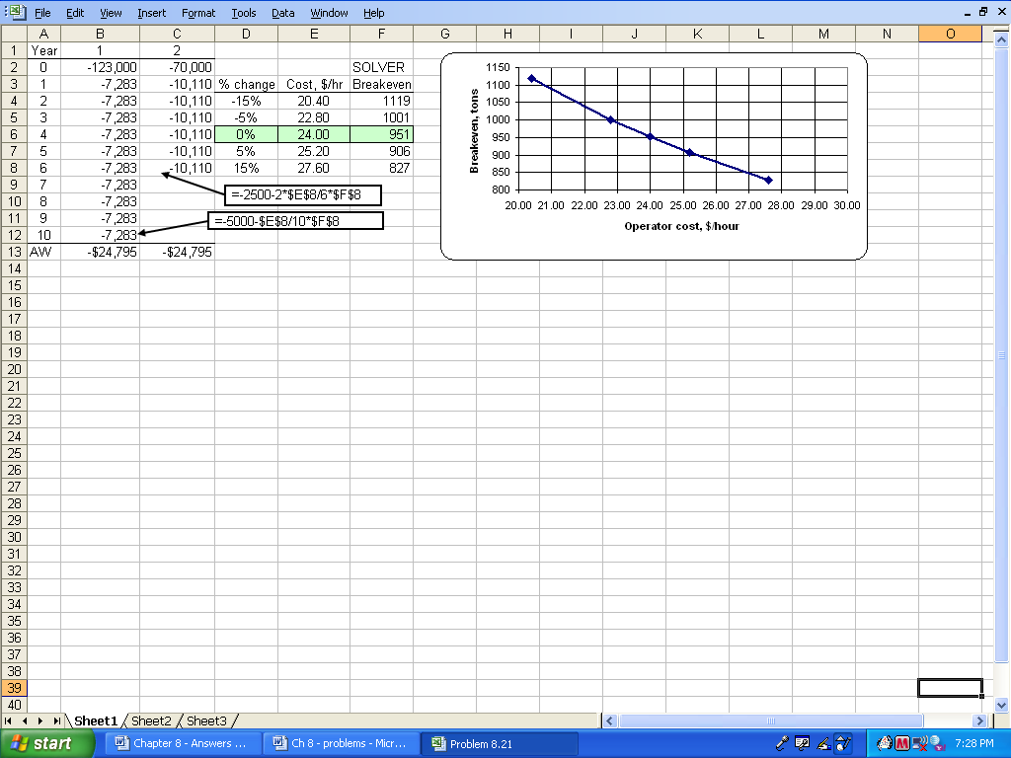

8.28 (a) Solve relation Revenue - Cost = 0 for Q = number of filters per year

50Q - [200,000(A/P,6%,5) + 25,000 + 20Q] = 0
30Q = 200,000(0.23740) +25,000
Q = 72,480/30
= 2416 filters per year

At 5000 units, make the filters inhouse

(b) Solve the relation AW_{buy} = AW_{make}

(50-30)Q = -72,480 + (50-20)Q
Q = 7248 filters per year

Since 5000 < 7248, outsourcing is the correct choice; slope of 30Q is larger

(c) Inhouse: make 5000 at $20 each

Profit = 5000(50-20) - 72,480 = $77,520

Outsource: buy 5000 at $30 each

Profit = 5000(50-30) = $100,000

A spreadsheet can be used to answer all three questions.

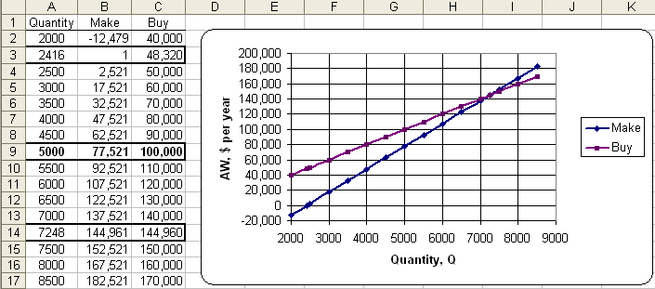

8.31 AW_{cont} = -130,000(A/P,15%,5) -30,000 + 40,000(A/F,15%,5)
= -130,000(0.29832) -30,000 + 40,000(0.14832)
= $-62,849

Lowest cost for batch will occur when the interest rate is the lowest (5%)
and life is longest (10 years)

AW_{batch} = -80,000(A/P,5%,10) – 55,000 + 10,000(A/F,5%,10)
= -80,000(0.12950) – 55,000 + 10,000(0.07950)
= $-64,565

Since batch AW is more costly, the batch system will never be less expensive than the continuous option.

8.34 AW_{current} = $-62,000

AW_{10,000} = - 64,000(A/P,15%,3) – 38,000 + 10,000(A/F,15%,3)
= - 64,000(0.43798) – 38,000 + 10,000(0.28798)
= $-63,151

AW_{13,000} = - 64,000(A/P,15%,3) – 38,000 + 13,000(A/F,15%,3)
= - 64,000(0.43798) – 38,000 + 13,000(0.28798)
= $-62,287

AW_{18,000} = - 64,000(A/P,15%,3) – 38,000 + 18,000(A/F,15%,3)
= - 64,000(0.43798) – 38,000 + 18,000(0.28798)
= $-60,847

The decision is sensitive; replace the existing process only if the estimate of
$18,000 is reliable.

8.37 (a) AW₁ = -10,000(A/P,i%,8) - 600 - 100(A/F,i%,8) - 1750(P/F,i%,4)(A/P,i%,8)
AW₂ = -17,000(A/P,i%,12) - 150 - 300(A/F,i%,12)
- 3000(P/F,i%,6)(A/P,i%,12)

Calculate AW at each MARR value. The decision is sensitive to MARR,
changing at i = 6%.

MARR AW₁ AW₂ Selection
4% $-2318 $-2234 2
6% $-2444 $-2448 1
8% $-2573 $-2673 1

(b) Spreadsheet solution requires that the PW value is first determined using the
NPV function over the LCM of 24 years and then converting it to an AW value
using the PMT function. Spreadsheet follows.

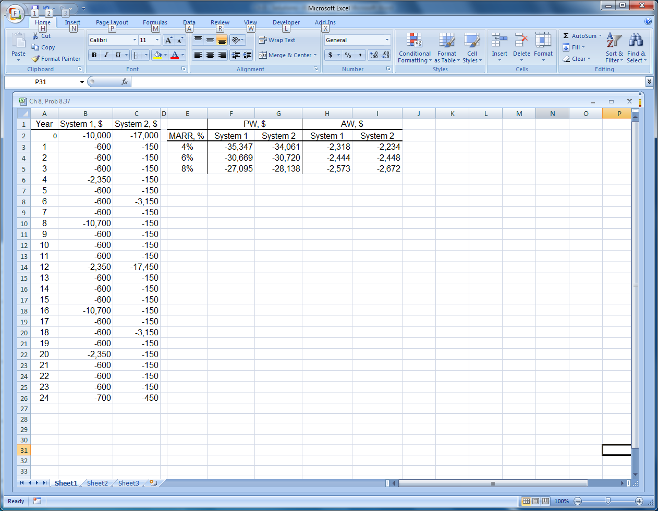

8.40 Hand solution: Determine AW values at different savings, s.

AW_{A} = -50,000(A/P,10%,5) – 7500 + 5,000(A/F,10%,5) + s
= -50,000(0.2638) – 7500 + 5000(0.1638) + s
= -19,871 + s

AW_{B} = -37,500(A/P,10%,5) – 8000 + 3700(A/F,10%,5) + s
= -37,500(0.2638) – 8000 + 3700(0.1638) + s
= -17,286 + s

Selection changes when s is +40% of best estimate. Table follows:

Percent  variation | Savings for A,  $ per year | AW_{A} | Savings for B,  $ per year | AW_{B} | Selection
-40% | 9,000 | $-10,871 | 7,800 | $-9,486 | B
-20 | 12,000 | -7,871 | 10,400 | -6,886 | B
0 | 15,000 | -4,871 | 13,000 | -4,286 | B
20 | 18,000 | -1,871 | 15,600 | -1,686 | B
40 | 21,000 | 1,129 | 18,200 | 914 | A

Spreadsheet solution: PMT functions display AW values with savings variation
added to end of function.

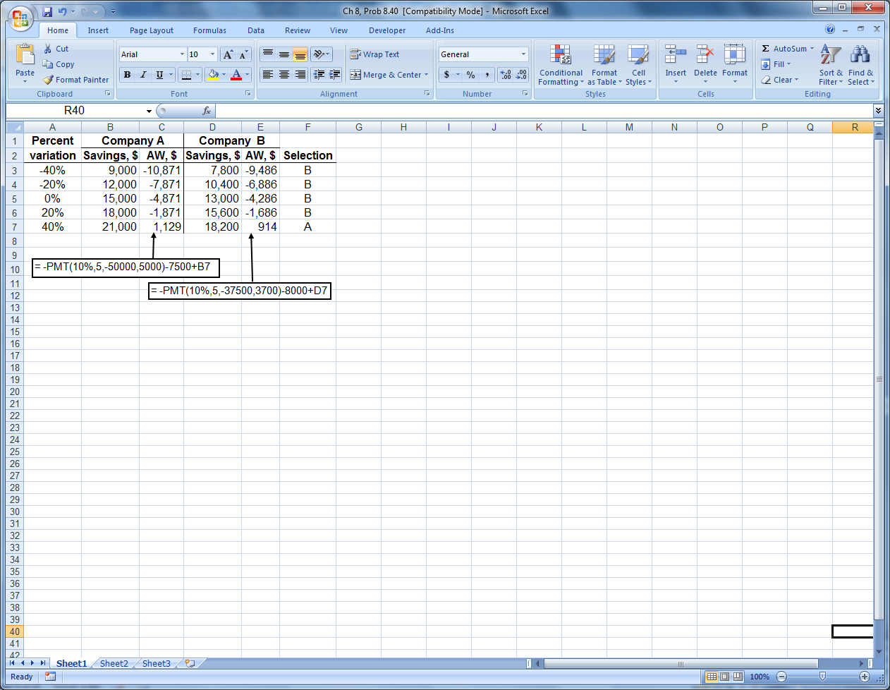

8.43 (a) Set up the general AW relation for D103 and determine AW for the three
scenarios.

AW_{D103} = -P(A/P,10%,n) + (0.1P)(A/F,10%,n) – 4000

Strategy | P | S | n | AW
Pess | -500,000 | 50,000 | 1 | $-504,000
ML | -400,000 | 40,000 | 3 | -152,761
Opt | -300,000 | 30,000 | 5 | -78,226

The AW_{490G} = $-135,143 is known. D103 is selected only if the optimistic
scenario is correct, i.e., P = $-300,000 and n = 5 years.

(b) Spreadsheet solution.

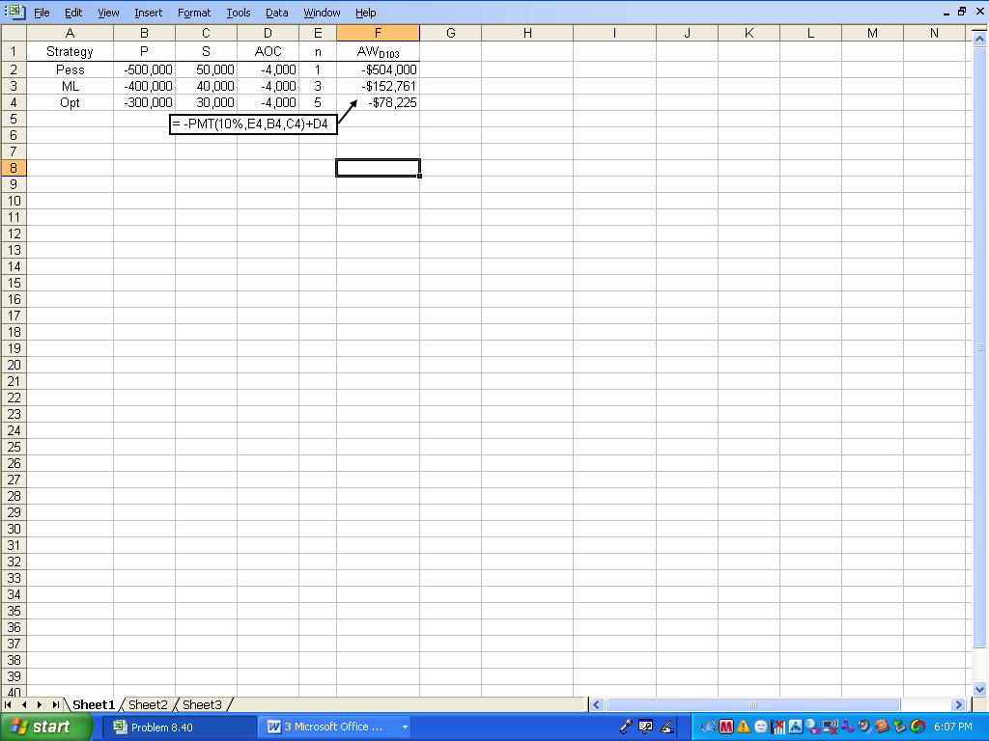

8.46 (a) Machine 1:
n_{p} = 40,000/10,000
= 4 years

Machine 2:
n_{p} = 90,000/15,000
= 6 years

Select only machine 1.

(b) Machine 1:
-40,000 + 10,000(P/A,10%,n_{p}) = 0
(P/A,10%,n_{p}) = 4.0000

From 10% interest tables, n_{p} is between 5 and 6 years; n_{p} > 5 years.

Machine 2:
-90,000 + 15,000(P/A,10%,n_{p}) = 0
(P/A,10%,n_{p}) = 6.0000

From 10% interest tables, n_{p} is between 9 and 10 years’ n_{p} > 9 years

Select neither alternative for further analysis

8.49 (a) Let n_{p} = number of months at 0.5% per month

0 = -90,000(A/P,0.5%,n_{p}) – 20,000 + 22,000
(A/P,0.5%,n_{p}) = 2000/90,000
= 0.02222

From 0.5% interest factor table, n_{p} is approximately 51 months

(b) Calculator function n(0.5,2000,-90000,0) displays n_{p} = 51.1 months

(c) Spreadsheet function =NPER(0.5%,2000,-90000) displays n_{p} = 51.1 months

8.52 Set up the PW relation and use trial and error or spreadsheet for n_{p}.

0 = -10,000 +1700(P/A,8%,n_{p}) + 900(P/F,8%,n_{p})

For n_{p} = 7: 0 = -10,000 +1700(5.2064) + 900(0.5835) = $-624
For n_{p} = 8: 0 = -10,000 +1700(5.7466) + 900(0.5403) = $+255
n_{p} = 7.7 years (interpolation)

Lease; don’t purchase
Spreadsheet: NPER(8%,1700,-10000,900) displays 7.7 years

8.55 (a) Determine i* from AW relations

AW₁ = -50,000(A/P,i*,5) + 24,000
(A/P,i*,5) = 0.4800
i₁* = 38.6% (interpolated)

AW₂ = -120,000(A/P,i*,10) + 42,000 – 2500(A/G,i*,10)
i₂* = 26.55% (trial and error or spreadsheet)

Now, select process 1

(b) First of all, an ROR analysis always requires an incremental analysis over the LCM of 10 years. The i₂* = 26.55% is not correctly used in the fashion shown here. Furthermore, this analysis assumes a return of 26.55% is made
from years 6 through 10, which may not be correct for these funds.

8.58 Both the fixed cost and variable cost of alternative X are higher than those of
alternative Y. Therefore, it can never be favored.

Answer is (a)

8.61 Answer is (a)

8.64 Answer is (c)

8.67 -100Q = -250,000(A/P,15%,4) – 80,000 – 40Q
60Q = 250,000(0.35027) + 80,000
Q = 2793

Larger than 2793 since slope of make item inhouse is lower
Answer is (b)

8.70 Select largest PW.

Answer is (d)

